Online Application Tracking – Data Interchange Specification (For Development Applications Only)
Note to Vendors
Two levels of data item groups for online DA application tracking are proposed in the enclosed specification.
Level 1 groups contain core data items, some of which are mandatory and others optional. Level 2 groups contain best practice data items and all Level 2 groups are optional.
Please note the Department is seeking the cooperation of application tracking software vendors to implement the Level 1 mandatory items only for online DA tracking. Future inclusion of a number of optional Level 1 data items and Level 2 data items will depend on resolution of legal questions related to copyright and privacy in the context of new planning legislation that is still in draft form and not yet in force.
Data items required for Level 1 Mandatory compliance for DA tracking are:

INFORMATION:
M/O Field Notes
--- ----------------------- ---------------------------------------------------------------------
M dat_id An id that uniquely identifies the application within this feed
M last_modified_date The date of the last change to this record
M description A short, human readable description of the application
M authority Name of the Authority
M lodgement_date Date the application was lodged with the Authority
M determination_date Date that the application was determined at the Authority
M status Current status of the application with the Authority
O notification_start_date Start date for notification period of application
O notification_end_date End date for notification period of application
O officer Name of responsible officer from the Authority
O estimated_cost Estimated cost of the work described by the application

REFERENCE:
M/O Field Notes
--- ----------------------- ---------------------------------------------------------------------
M more_info_url Web address for more information about this application
O comments_url Web address for commenting on this application

LOCATION:
M/O Field Notes
--- ----------------------- ---------------------------------------------------------------------
M address Human readable street address for the application
M land_title_ref Composite record containing Land Title Office references
M lot Lot number, or “none”
M section Section number, or “none”
M dpsp_id DP/SP identifier, or “none”
O geometry Composite record containing geographic coordinates (GeoJSON format)

DOCUMENTS:
M/O Field Notes
--- ----------------------- ---------------------------------------------------------------------
M documents Composite record containing a list of documents for the application
M ref Internal reference of document for this application
M title Short, human readable title of the document
M document_url URL to location of document for download

EVENTS:
M/O Field Notes
--- ----------------------- ---------------------------------------------------------------------
M events Composite record containing a list of events for the application
M id Internal id of event raised against application
M date Date the event occurred
M description Short, human readable description of the event
O event_type Authority-specific event type
O status Authority-specific event status code

Please see section 4 (page 19) for complete details.
The Department may consider introducing data interchange specifications for online tracking of complying development, DA modifications (s96) and other types of application in the future as separate projects.
Thank you
ePlanning Team

NSW Department of Planning and Infrastructure
Level 3, 66 Harrington Street, The Rocks, Sydney NSW 2000
P: 02 8575 4045
F: 02 8575 4077
ecode@planning.nsw.gov.au

ATDIS-1.0.7 Application Tracking
Data Interchange Specification

Version | 1.0 (30)
Status | Published
Printed | 13/09/2013 1:02 PM
Reference | 0000.doc
Prepared by | Carpadium Pty Ltd  www.carpadium.com

Introduction
The NSW Department of Planning and Infrastructure (Department) has released the White Paper: A New Planning System for NSW. Chapter 4: Community Participation, informs the community of the direction for ePlanning in NSW. One of the ePlanning deliverables under the White Paper is making Application Tracking universally available to the community online.
The main objective of the Application Tracking project is to help every Council in NSW work with a software vendor of their choice to implement an electronic application tracking tool that can extract application information from their electronic management systems in a machine readable format for people across NSW to access online. Making this information universally and easily available online requires a common standard for recording and extracting application tracking information from council electronic management systems.
The purpose of this document is to provide vendors of application tracking software with a draft Application Tracking Data Interchange Specification for their review and comment and invite them to participate in the Application Tracking project.
Specific goals for this project are:
- Agree a common machine-readable standard for data produced by application tracking tools.
- Agree a minimum set of fields that a vendor's product must be able to produce.
- Agree a best-practice set of fields that a Council should be aiming for, along with legal advice from the Department as to the right to display these.
- Provide financial incentives to Councils to acquire or update an application tracking tool that meets (1) and (2).
- Make it easy for other parties (such as planningalerts.org.au) to consume the data produced by the tools deployed under (4).
Please note the Department is explicitly not trying to:
- Commission the build of new application tracking software.
- Compete with existing vendors in the marketplace.
- Dictate to Councils which vendor they should choose for their needs.
- Dictate to vendors how they should build their systems or limit the features their products contain.
However, the Department is seeking vendor cooperation to adopt common State-wide standards for Application Tracking Software to enable universal community access to an agreed set of application tracking information on line.
Once the Department has established an agreed specification through consultation with vendors and other stakeholders, it will commission development of a test harness for vendors to use (at no cost to vendors) to test and confirm their application tracking software complies with the agreed specification.
The Department also intends to offer funding support to Local Government and start to release grants this financial year to help them pay for modification work on their electronic workflow management systems necessary to support application tracking. For those vendors who will need to make significant modifications to their software so that it meets the agreed final specification for the minimum set of fields and eventually the full best practice set of fields, the Department is willing to discuss and explore options for how they might do this.
For more information regarding this invitation, please contact the ePlanning Project Team at ecode@planning.nsw.gov.au quoting Application Tracking in the email heading and providing contact details for the person in your organisation who should be contacted.
The Department looks forward to working with all vendors collaboratively on this project.
Table of Contents
Introduction 4
Table of Contents 5
Figures 8
1 Context 9
1.1 Revisions 9
1.2 Definitions 9
1.3 About this document 9
1.4 Specification process 9
1.4.1 Steps 9
1.4.2 Feedback 10
2 About the specification 11
2.1 Introduction 11
2.2 Examples 11
2.2.1 Scenario 1: Get a list of all active development applications from a local government area 11
2.2.2 Scenario 2: Get a list of active development applications within a specific postcode 13
2.2.3 Scenario 3: Register for an email alert on status change of an active development application 13
2.3 Goals and objectives 13
2.3.1 What the ATDIS interchange specification is 14
2.3.2 What the ATDIS interchange specification is not 14
2.4 Approach 14
2.5 Success criteria 14
2.6 Complying with the specification 14
2.7 Considerations 15
3 Conceptual architecture 16
3.1 Roles and responsibilities 17
4 ATDIS-1.0.7 Application Tracking Data Interchange Specification 18
4.1 Components of the specification 18
4.2 Feed 19
4.3 Schema 20
4.3.1 Info [L1] 21
4.3.2 Reference [L1] 21
4.3.3 Location [L1] 22
4.3.4 Events [L1] 23
4.3.5 Documents [L1] 23
4.3.6 People [L2] 23
4.3.7 Extended [L3] 24
4.3.8 Date Formats [L1] 24
4.4 Other Technical Considerations 24
4.4.1 Encoding 24
4.4.2 Mandatory Fields 24
5 Use Cases 25
5.1 Operational Use Cases 25
5.1.1 List all development applications for [Council] 26
5.1.2 List all development applications for [Council] for [Period] 26
5.1.3 List all development applications for [Council] in [Postcodes] 26
5.1.4 Get more information about development application [Id] 26
5.1.5 List all development applications 27
5.1.6 Notes on paging 27
5.2 Specification Use Cases 28
5.2.1 Create ATDIS specification 28
5.2.2 Manage ATDIS specification lifecycle 28
5.2.3 Comply with ATDIS specification 28
5.2.4 Produce compliant tracking data 28
5.2.5 Implement ATDIS specification 28
5.2.6 Deploy ATDIS-compliant software 29
6 Distribution Channels 30
6.1 REST/JSON [L1] 30
6.2 REST/XML [L1] 30
6.3 Browser [L1] 30
6.3.1 Web Standards and Accessibility 30
6.3.2 Desktop and mobile browser support 31
6.4 RSS [L3] 32
6.5 Paging [L2] 33
7 Compliance 35
7.1 Compliance requirements 35
7.1.1 General 35
7.1.2 Schema 35
7.1.3 Use cases 36
7.1.4 Distribution channels 36
7.2 Compliance and certification process 36
7.3 Obtaining certification 37
7.4 Using "ATDIS-1.0.7 Data Interchange Specification Compliant" in Vendor software marketing 37
8 Lifecycle 38
8.1 Version history 38
8.2 Changed in this version 38
8.2.1 Data items 38
8.2.2 Use cases 38
8.2.3 Distribution channels 38
8.3 Deprecated in this version 38
8.3.1 Data items 38
8.3.2 Use cases 38
8.3.3 Distribution channels 38
8.4 Planned for deprecation in the next version 38
8.4.1 Data items 38
8.4.2 Use cases 38
8.4.3 Distribution channels 38
8.5 Planned for addition in the next release 38
8.5.1 Data items 38
8.5.2 Use cases 39
8.5.3 Distribution channels 39
9 Appendix 1: Future possibilities 40
9.1 Subscription and publication of ATDIS events 40
9.2 Extended/enhanced attribute publication 40
10 Appendix 2: Examples of compliant ATDIS-1.0.7 requests and responses 41
10.1 Obtain a list of all applications 41
10.2 Obtain a list of all applications for a set of postcodes 42
11 Appendix 3: Carpadium Pty Ltd 43
11.1 About Carpadium 43
11.2 Carpadium's role in the specification process 43

Figures
Figure 1: Conceptual architecture 16
Figure 2: Components of the specification 18
Figure 3: Feed web address format 19
Figure 4: Feed structure 20
Figure 5: Operational use cases 25
Figure 6: Specification use cases 28

Context

Revisions
20130913:v1.0 Matthew Sinclair – Final refinements based on feedback after production of test harness
20130812:v1.0 Matthew Sinclair – Final updates for final draft to add events and documents blocks to Level 1
20130611:v1.0 eCode Team – Invitation to vendors update plus clarification edits to sub-sections 2.1 and 2.2
20130605:v0.9 Matthew Sinclair – Update to fix some errors in JSON formatting
20130531:v0.8 Matthew Sinclair – Update to fix contradiction in date usage note in 4.3.1
20130524:v0.7 Matthew Sinclair – Further updates based on feedback from Open Australia Foundation
20130524:v0.6 Matthew Sinclair – Updates based on feedback from Open Australia Foundation
20130517:v0.5 Matthew Sinclair – Updates following vendor feedback, pre-publication
20130505:v0.4 Matthew Sinclair – Changed name to ATDIS, edits after feedback from DPI
20130501:v0.3 Matthew Sinclair – Wrapping up draft for distribution to Vendors
20130422:v0.2 Matthew Sinclair – Updates after initial workshop
20130420:v0.1 Matthew Sinclair – Initial version

Definitions
- Department: NSW Department of Planning and Infrastructure
- AT: application tracking
- DIS: data interchange specification
- Specification: this document
- Specifying Authority: the Department of Planning and Infrastructure acting to create and manage the ATDIS-1.0.7 data interchange specification.
- Complying Authority: the Local Government Area or Municipal Council that processes development applications and makes them available in compliance with the ATDIS-1.0.7 data interchange specification.
- LGA: Local Government Area
When describing a component for compliance, the Specification will make use of one or more of the following key words: "MUST", "MUST NOT", "REQUIRED", "SHALL", "SHALL NOT", "SHOULD", "SHOULD NOT", "RECOMMENDED", "MAY", and "OPTIONAL". The key words are to be interpreted as described in RFC 2119.

About this document
The first part of this document presents a narrative explanation of the Specification and the process the Department is using to collaboratively develop it with software vendors and Councils. The second part of the document describes the specification in detail using formal language suitable for use in compliance verification.

Specification process

Steps
- Prepare straw man Specification (this document)
- Workshop straw man Specification with vendors and Department of Planning & Infrastructure
- Refine straw man Specification post-workshop [Carpadium]
- Distribute post-workshop straw man Specification to all parties for review [Carpadium]
- Provide feedback on straw man specification [Vendors]
- Arrange a 1-1 meeting with Carpadium to discuss Specification requirements and any confidential feedback topics [Vendors, Carpadium]
- Collate and integrate feedback into Draft Specification [Carpadium]
- Publish Beta Specification for final comments [Carpadium]
- Collate and integrate feedback into Final Specification for publication
- Publish finalised documents as ATDIS-1.0.7 Specification

Feedback
Please address all feedback on this version of the Specification to info@carpadium.com with the subject "ATDIS-1.0.7 Data Interchange Specification [version: 1.0, revision: 30]".

About the specification

Introduction
This document presents the final draft version of the ATDIS-1.0.7 Specification for State-wide application tracking for the NSW Department of Planning & Infrastructure.
In preparing this Specification, the Department is striving to give the residents of NSW the ability to track the status of development applications online in a consistent, timely and complete manner, with a view to enabling a bird's eye view of development applications across the State of NSW.
This specification is concerned with providing online access to publically available application tracking data in accordance with this specification. It is not a specification for application software nor is it an attempt by the Department to prescribe or proscribe any application functionality or seek in any way to control or specify the software functionality of application tracking systems offered by Vendors.
This version of the Specification [1.0, revision 30] has now been a review cycle within the Department and with Vendors, and is ready for publication as the final draft.

Examples
The following examples describe some of the simplest and most common interactions that the specification hopes to foster. In each case, the important details relate to the business scenario triggering the event, and the data captured and interchanged in that process.
The examples assume familiarity with local government development planning tracking processes, as well as standard Internet protocols.

Scenario 1: Get a list of all active development applications from a local government area
The simplest scenario that the specification seeks to guide is the process of obtaining a list of currently active development applications from a specific local government area (LGA).
To satisfy this business scenario, a Resident visits the public website of the LGA and clicks on a link to present the development tracking list. Within the LGA's software system a query executes to generate a list of currently active development applications, which the vendor's software system formats for display in the Resident's browser.
It is important to stress that the ATDIS-1.0.7 Specification does not seek to control how the Vendor's software stores or processes development planning information, the business work flows used to create it, or even how the information is visually styled and displayed on the screen. However what the Specification does concern itself with is the data items that make up the information displayed.
For example, the following presents an indication of the types of data items and their naming conventions for a single development application:

{
"response": [
{
"application": {
"info": {
"dat_id": "DA2013-0381",
“last_modified_date”: “2013-04-20T02:01:07Z”,
"description": "New pool plus deck",
"authority": "Example Council Shire Council",
"lodgement_date": "2013-04-20T02:01:07Z",
"determination_date": "2013-06-20T02:01:07Z",
"notification_start_date": "2013-04-20T02:01:07Z",
"notification_end_date": "2013-05-20T02:01:07Z",
"status": "OPEN"
},
"reference": {
"more_info_url": "http://www.examplecouncil.nsw.gov.au/atdis/1.0/applications/DA2013-0381"
},
"location": {
"address": "123 Fourfivesix Street Neutral Bay NSW 2089",
"land_title_ref": {
"lot": "10",
"section": "ABC",
"dpsp_id": "DP2013-0381"
}
}
}
},
{
"application": {
...
}
}
],
"count": 2,
"pagination": {
"previous": null,
"next": null,
"current": 1,
"per_page": 25,
"count": 100,
"pages": 1
}
}

The way in which this data is rendered in a browser from the LGA's web site is entirely up to the LGA and their software vendor, but the hope is that an ATDIS-1.0.7-compliant system would be able to provide the above data items as a minimum set.
Importantly, the Specification seeks to influence vendors of LGA systems to provide programmatic access to this kind of data for consumption by other systems, residents and applicants, as well as the Department and content aggregators.
The preferred mode of system-to-system integration is via standard, open web protocols. For example, an HTTP request for a URL of the following form could yield the above application data:

REQ: GET http://www.examplecouncil.nsw.gov.au/atdis/1.0/applications.json
RES: 200 OK

The exact structure of the URL is defined later in the specification, but the important point to note here is that the URL represents an address to which a remote system can make a standard HTTP(s) GET request, with the expectation that a list of development applications will be returned in a machine readable format (in this case JSON, but XML would be equally appropriate). The basic interaction described here is the same for all use cases indicated within the Specification.
In summary, a remote system makes a request using standard HTTP protocols to an address in a known format, and the system returns a machine-readable data set for consumption by the remote system.

Scenario 2: Get a list of active development applications within a specific postcode
A simple refinement of Scenario 1 is to qualify the request so that the LGA system returns a subset of the available data. For example, a Resident might wish to know about all development applications within a specific postcode:

REQ: GET http://www.examplecouncil.nsw.gov.au/atdis/1.0/applications.json?postcodes=2089
RES: 200 OK

The above request contains a query string ("postcodes=2089") that informs the LGAs system that instead of returning all development applications, that it should only return applications for the postcode 2089. The format of the returned data would be identical to that in Scenario #1, with the expectation that only those applications in the specified postcode would be returned.
A client system could also make a request for multiple postcodes, for example:

REQ: GET http://www.examplecouncil.nsw.gov.au/atdis/1.0/applications.json?postcodes=2089,2090
RES: 200 OK

This is useful for when a local government area occupies multiple postcodes, or for when a resident might interested in applications at the boundary of more than one postcode.

Scenario 3: Register for an email alert on status change of an active development application
Although this version of the specification does not include alerts as part of the mandatory sections, this scenario is an example of the kind of future development possibilities for the specification. For example, a Vendor or aggregator may wish to add alert subscription capability for residents that can be used for notification when the status of an application changes.
The following presents an indicative example of how one might add an email alert for changes in state for a development application:

REQ: POST http://www.examplecouncil.nsw.gov.au/atdis/1.0/applications/DA2013-0381/notifications
{
"notification": [
{
"email": "resident@example.com.au"
}
]
}
RES: 201 Created

Note: this example has intentionally left out considerations such as authentication or other issues associated with remotely posting data into an LGA system. Definition of those protocols is beyond the scope of the ATDIS-1.0.7 Specification.

Goals and objectives
In creating the Specification, the Department seeks to:
- Create an interchange format for the data associated with development applications that allows publicly available information to be published in a consistent fashion to foster integration and aggregation
- Give the residents of NSW confidence that their Councils are collecting and publishing relevant application tracking data in a consistent, timely and complete manner
- Facilitate creation of a bird's eye view of development applications across NSW

What the ATDIS interchange specification is
- It is a specification that codifies the types of data that Council has to capture and make available for residents
- It is a specification for a data interchange format for application tracking
- It is designed to make publishing application tracking data simple and easy for system-to-system integration

What the ATDIS interchange specification is not
- It is not a specification for a software application
- It is not a specification for application functionality
- It is not a solicitation for provision of software or services

Approach
The Department is seeking to collaboratively develop the Specification with interested parties including councils and vendors of software systems that offer tracking capabilities.
Specifically, the Department hopes to:
- Collaboratively create a new data interchange standard for the online publication of data associated with development applications
- Work with vendors of municipal software systems to deliver application tracking tools for Councils that are interoperable according to Department of Planning & Infrastructure standards

Success criteria
To be successful, this specification must:
- Achieve industry wide consensus from all stakeholders on the Specification, including:
  - Schema: the format for publicly available mandatory, optional and extended data items published by application tracking systems
  - Use Cases: an agreed minimum set of expected uses for published application tracking data
  - Channels: an agreed minimum set of channels and data syntax models over which application tracking data can be published
- Achieve sign-off of version 1.0 of the Specification from the Department

Complying with the specification
In order to comply with the Specification, Complying Authorities must work with ATDIS Vendors and their own IT infrastructures to publish information about development applications so that Applicants and other Residents within NSW can access that information online through browser or mobile devices.
Implementations of systems seeking compliance with the Specification can do so at one of three levels of compatibility:
- Level 1. Mandatory
- Level 2. Optional
- Level 3. Extended
The Department acknowledges from the outset that there are different levels of technical capability within councils and varying degrees of maturity of the software systems employed to manage application tracking. For this reason, the Specification defines three levels of compliance to allow flexibility for both Councils and software vendors.
Level 1 Mandatory captures the basic set of data items necessary for any kind of meaningful display of application tracking data. The ATDIS-1.0.7 specification sets out to capture the baseline set of data items that all Councils with application tracking software should be able to meet, and defines an interchange format that is both simple and easy for Residents and Applicants to consume, and suitable for Aggregators to work with.
Level 2 Optional captures what the Department believes is best practice for the management of online application tracking data. The Department realises that not all Vendors or Councils are equipped to provide data interchange to Level 2, and so the Level 2 components of the specification exist to provide a stretch target for Councils and Vendors.
Level 3 Extended provides an opportunity for Vendors and Councils to innovate on top of the baseline ATDIS-1.0.7 specification. This version intentionally leaves Level 3 attributes unspecified, but recognises that some Vendors and Councils will have items suitable for publication as extended data that can be used to differentiate the software Vendor and/or their implementing Councils.
To comply with the Level 1 Mandatory components of the Specification, a Complying Authority's application tracking system must be able to:
- Provide an online feed of development applications processed by the Complying Authority that:
- Contains each of the mandatory data items,
- Supports consumption according to the mandatory use cases, and
- Presents data across each of the mandatory distribution channels,
as defined in the ATDIS-1.0.7 version of the Specification.
To achieve Level 2 Optional compliance, a Complying Authority's application tracking system must be able to:
- Provide an online feed of development applications processed by the Complying Authority that:
- Contains each of the optional data items,
- Supports consumption according to the optional use cases, and
- Presents data across each of the optional distribution channels,
as defined in the ATDIS-1.0.7 version of the Specification.
And to achieve Level 3 Extended compliance, Complying Authority's application tracking system must be able to:
- Provide an online feed of development applications processed by the Complying Authority that:
- Contains each of the extended data items,
- Supports consumption according to the extended use cases, and
- Presents data across each of the extended distribution channels,
as defined in the ATDIS-1.0.7 version of the Specification.
In the context of compliance, a feed is a public data set that is available for consumption by a person using a desktop or mobile browser and Internet protocols such as IP and HTTP(s), or by a system capable of interacting with the feed using the same Internet protocols.

Considerations
Based on feedback from stakeholders, the following list of considerations is relevant for Vendors and Councils wishing to develop compliant systems:
- Authentication: The Specification introduces no authentication requirements and makes the assumption that compliant data is available via a public, unauthenticated link.
- Throttling: Vendors and councils are free to implement throttling against a reasonable use policy. The definition of fair use is beyond the scope of the specification.

Conceptual architecture
Figure 1 presents the conceptual architecture for the Specification:
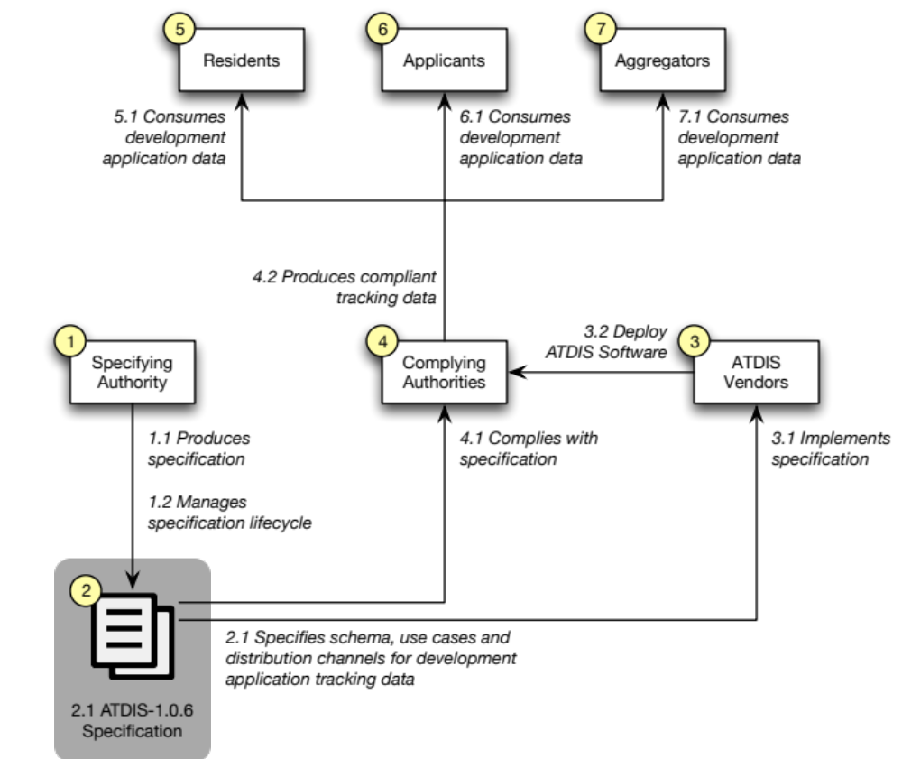
Figure 1: Conceptual architecture
The conceptual architecture defines the high-level entities and processes that cooperate within the specification. This Specification document is principally concerned with defining the schema, use cases and distribution channels for the ATDIS-1.0.7 data interchange format.
Entities and activities are captured in the conceptual architecture to provide context.

Roles and responsibilities
This specification attempts to coordinate the publicly available data captured and produced by application tracking systems, and in doing so, necessitates defining responsibilities for a number of roles within the ecosystem
The Specification defines the following roles:
- Specifying Authorities: The NSW Department of Planning & Infrastructure acts to create the Specification for application tracking data, and manage the lifecycle of change to the specification over time.
- Complying Authorities: Councils work to comply with the publication standard codified in the Specification and use ATDIS Vendor software to produce compliant tracking data.
- ATDIS Vendors: implement the specification in their municipal systems and deploy to NSW Councils.
- Residents: consume application tracking data for other applicants via online and/or mobile channels.
- Applicants: consume application tracking data for their own applications and the applications of other residents via online and/or mobile channels.
- Aggregators: consume application tracking data and aggregate according to market requirements.
The Specification captures a number of responsibilities that indicate how each role participates in the inputs and outputs of the ATDIS-1.0.7 process:
- Specifying Authority
  - Produces specification
  - Manages specification lifecycle
- ATDIS-1.0.7 Specification
  - Specifies schema, use cases and distribution channels for application tracking data
- ATDIS Vendor
  - Implements Specification
- Complying Authority
  - Complies with Specification
- Resident
  - Consumes application tracking data
- Applicant
  - Consumes application tracking data
- Aggregator
  - Consumes application tracking data
Note: It is well understood that participants in this ecosystem have other roles and perform a variety of other responsibilities that are beyond the scope of this Specification. These roles and responsibilities are described for clarity within this Specification, and are not meant to constrain the operation of those entities in activities beyond the scope of the Data Interchange Specification.

ATDIS-1.0.7 Application Tracking Data Interchange Specification

Components of the specification
Figure 2 presents the four high-level components of the Specification:
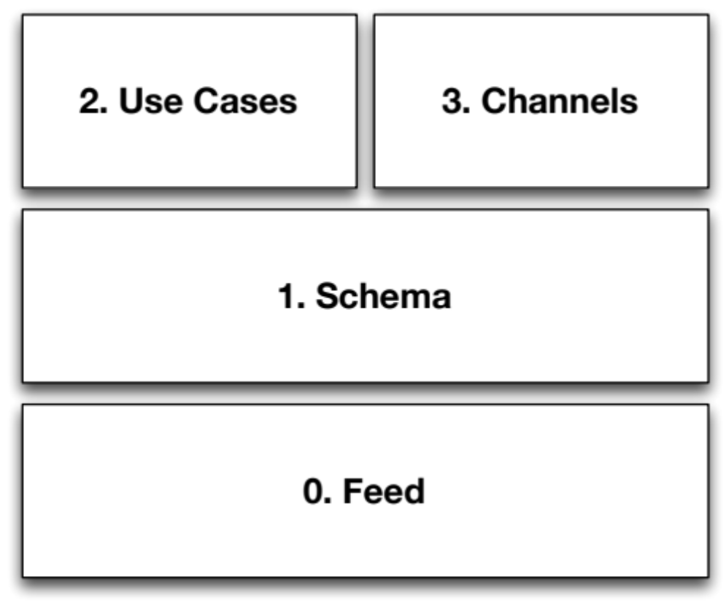
Figure 2: Components of the specification
- Feed: defines a publicly available source of application tracking data. For example, each complying Council would provide a single feed for application tracking data.
- Schema: defines the data elements that make up individual application tracking records. Examples include "date", "location" and "reference".
- Use cases: defines the agreed use cases for which ATDIS data can participate. Examples include "enquiries" and "subscriptions".
- Channels: defines the channels over which ATDIS data can be delivered. Examples include RSS, REST/[JSON, XML] and Browser.

Feed
Any compliant source of application tracking data is referred to as a feed. A feed is defined by a standard web address of the form:
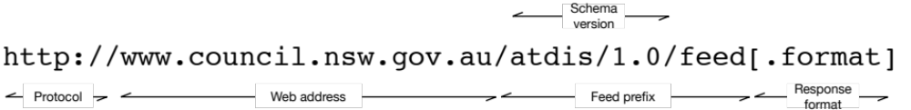
Figure 3: Feed web address format
Where
- Protocol: assume HTTP, but HTTPS can be used by a Council if required
- Web address: the fully qualified web host name for the Complying Authority. By convention, this should be the same as the URL used to access the Council's publicly available web site.
- Feed prefix: component of the URI that indicates a complying feed.
- Schema version: component of the feed prefix that indicates the version of the schema offered by the feed.

Notes
- There are some options for how the schema version number might be encoded into the feed URL. The above format (where the version is encoded into the URI) is the simplest mechanism, but it is also possible to encode version number with an HTTP header variable, with a query string parameter, or by using content negotiation. There is a vibrant and passionate debate about the best way to version URLs for access to resources that shows no prospect of being settled soon. Therefore, for the purposes of ATDIS-1.0.7, a simple URI-encoded version string is proposed. If content negotiation becomes the preferred standard, then this it is relatively easy to change the prefix in a future release.
- Given a version of the specification of the form MAJOR.minor.patch, it is assumed that all patch versions of the same major/minor version remain semantically and syntactically compatible with each other. Minor may introduce new items but will not remove any existing items. Major versions may make changes to the schema that are not backwards compatible.

Schema
The schema defines the specific data elements that are published in a compliant ATDIS-1.0.7 feed. The schema has a defined structure, broken down into one or more application records, which are further decomposed into blocks and fields.
To comply with the Specification at any level, a feed must support the basic conceptual structure of a list of application records. Then the feed will provide blocks and fields for each application record, depending on the level of compliance.
If a feed chooses to include a record type then it must include all mandatory fields for that record type. A feed can chose whether or not to include any optional fields within a block.
Figure 4 describes the conceptual structure of a complying feed:
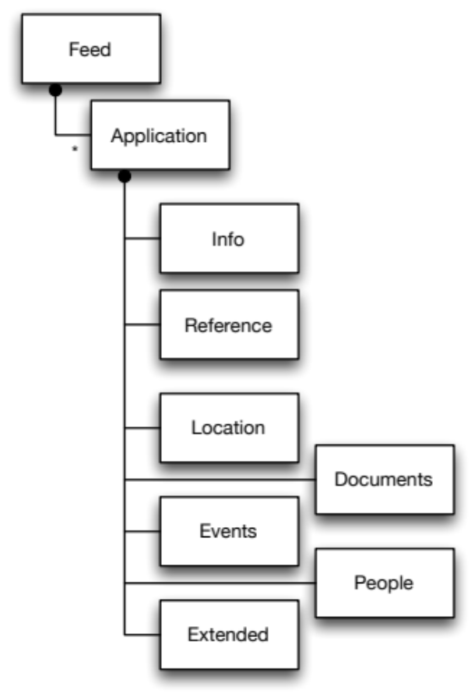
Figure 4: Feed structure
There are seven record types defined by the Specification:
- Info
- Reference
- Location
- Events
- Documents
- People
- Extended
The following sections describe the semantics of each of the seven record types that make up the Specification. For each record type, the Specification indicates in which compliance level (L1, L2 or L3) the record belongs.

Info [L1]
The info record is the top-level block that contains unique identifying information about a single development application. In conjunction with the reference block, this represents the minimum Level 1 Mandatory requirements for a feed compliant with the ATDIS-1.0.7 specification.
The info record must contain the following fields:

M/O Field Notes
--- ----------------------- ---------------------------------------------------------------------
M dat_id An id that uniquely identifies the application within this authority
M last_modified_date The date of the last change to this record
M description A short, human readable description of the application
M authority Name of the Authority
M lodgement_date Date the application was lodged with the Authority
M determination_date Date that the application was determined at the Authority
M status Current status of the application with the Authority
O notification_start_date Start date for notification period of application
O notification_end_date End date for notification period of application
O officer Name of responsible officer from the Authority
O estimated_cost Estimated cost of the work described by the application

Notes
- The field last_modified_date captures the date at which the authority last modified the record. This allows consuming systems to know if an application changes over time.
- Dates can be specified with or without time information. For example, the following are both valid date values (see also 4.3.8):
"determination_date": "2013-06-20T02:01:07Z"
"determination_date": "2013-06-20"
- If the application does not have a determination date (yet, or at all), the value “none” should be specified for the determination_date field.
- If the application does not have a notification period at all, the value “none” should be specified for the notification_start_date and notification_end_date fields.
- The contents of estiamted_cost and should be a formatted currency string in Australian Dollars, of the form “$300,000”.

Reference [L1]
The reference record contains links to the original source material for the application at the Complying Authority. It can optionally contain a link for where Residents can comment on the application at the Complying Authority. In conjunction with the info block, this represents the minimum Level 1 Mandatory requirements for a feed compliant with the ATDIS-1.0.7 specification.
In both cases, the links to URLs captured in the reference block would take the user to another location on the Complying Authority's web site.
The content behind the more_info_url and comments_url values must link to an endpoint that directly shows the information for the specific development application. The underlying content must be directly accessible without authentication, cookies or other limiting requirements for the consuming system. The data and behaviour of the pages at these links is beyond the scope of the ATDIS-1.0.7 Specification.
The reference record must contain the following fields:

M/O Field Notes
--- ----------------------- ---------------------------------------------------------------------
M more_info_url Web address for more information about this application
O comments_url Web address for commenting on this application

Location [L1]
The location record is designed to provide consumers with information about the geographic location of the development application. Because not all Authorities have access to geographic information for their development applications, parts of this record are optional. If a feed includes the location record at all, it must include the address and land_title_ref attributes within the record.
It is mandatory that feeds provide the location record with the address and land_title_ref fields, and it is anticipated that future versions of the Specification will promote the coordinates field into mandatory compliance.

M/O Field Notes
--- ----------------------- ---------------------------------------------------------------------
M address Human readable street address for the application
M land_title_ref Composite record containing Land Title Office references
M lot Lot number, or “none”
M section Section number, or “none”
M dpsp_id DP/SP identifier, or “none”
O geometry Composite record containing geographic coordinates (GeoJSON format)

Notes
- In each case the values for lot, section and dpsp_id should all be captured as strings.
- When used, GPS coordinates must make use of the WGS84 datum as per "Earth Gravitational Model 2008 (EGM2008)”. See: http://earth-info.nga.mil/GandG/wgs84/gravitymod/egm2008/index.html for details.
- The format for geographic coordinates must use the GeoJSON specification as per: http://geojson.org/geojson-spec.html#geojson-objects
- The simplest compliant version of a geometry instance would be a Point of the form:

{ "type": "Point", "coordinates": [100.0, 0.0] }

Point coordinates are in x, y order (easting, northing for projected coordinates, longitude, latitude for geographic coordinates). For more advanced geometric types, please refer to the GeoJSON specification.
- As geometry is optional for the Location block in ATDIS-1.0.7, there is no requirement to specify the kinds of geometric data for an application. However, if a feed is supplying geometric data, then it must be formatted according to the GeoJSON specification.
- In general, the dpsp_id will start with either the letters SP or DP, and be followed by a number.
- If any of the values for land_title_ref are not available, then they should be populated with the value “none”.

Events [L1]
The events record contains a list of events that have occurred against the application since lodgement. In this version of the specification, the events block has been promoted to Level 1 Mandatory. The events record must include a list of events, where each event has an id, date and description. Inclusion of an event_type and status is optional.

M/O Field Notes
--- ----------------------- ---------------------------------------------------------------------
M events Composite record containing a list of events for the application
M id Internal id of event raised against application
M date Date the event occurred
M description Short, human readable description of the event
O event_type Authority-specific event type
O status Authority-specific event status code

Notes
- This version of the specification does not define a list of valid event_types, so the contents of this field can be Vendor or Council specific.
- The value for id should be a string. The value should be unique from the perspective of the authority such that it can be used as a reference for the underlying event.

Documents [L1]
The documents record contains a list of references (as links) to documents that relate to the application. In this version of the Specification, the documents block has been promoted to Level 1 Mandatory. The documents record must include a list of documents, where each document has a ref, title and a link (in the form of a URL) to the location where the document can be downloaded.

M/O Field Notes
--- ----------------------- ---------------------------------------------------------------------
M documents Composite record containing a list of documents for the application
M ref Internal reference of document for this application
M title Short, human readable title of the document
M document_url URL to location of document for download

People [L2]
The people record contains a list of people that relate to the application. As an extended data item, this record is only required for Level 2 Optional compliance. However, if it the people record is included at all, then it is assumed to include a list of people, where each person has a name and a role indicating their responsibility with the application. Optionally, the person record can include contact information.

M/O Field Notes
--- ----------------------- ---------------------------------------------------------------------
M people Composite record containing a list of people related to the app
M name Name of person related to the application
M role Authority-specific role type for the person with respect to the app
O contact Authority-specific contact information for the related person

Extended [L3]
The extended record is specifically designed to allow ATDIS-1.0.7 compliant feeds to include any additional information that might be relevant to an application. The contents of the extended record is not specified, and left up to the ATDIS Vendor and Complying Authority to populate as they see fit. There are no mandatory or optional fields for the extended record. Consuming systems should expect its existence, but are not required to do anything with data contained within it.

M/O Field Notes
--- ----------------------- ---------------------------------------------------------------------
Not specified

Date Formats [L1]
Any field within the schema of the form *_date should be treated as an ISO-8601 date format. See: http://www.w3.org/TR/NOTE-datetime for details.

Other Technical Considerations

Encoding
All data in ATDIS requests should be encoded using UTF-8, and all data returned by ATDIS-compatible systems should be returned in UTF-8 encoding. See http://en.wikipedia.org/wiki/UTF-8 for details.

Mandatory Fields
If for any reason an authority’s feed is unable to provide data for a particular field that is considered mandatory for the specification, then the feed should include the field and populate it with the value “none”.

Use Cases
The specification defines a number of use cases to assist with scoping. The pre-draft version considers two kinds of use cases:
- Operational use cases
- Specification use cases
Operational use cases describe the scope of use of systems that comply with the specification.
Specification use cases describe of the specification process itself. It is likely that the specification use cases will be deprecated and removed before release of the final version of the ATDIS-1.0.7 specification.

Operational Use Cases
Figure 5 presents the top-level operational use cases for ATDIS-1.0.7:
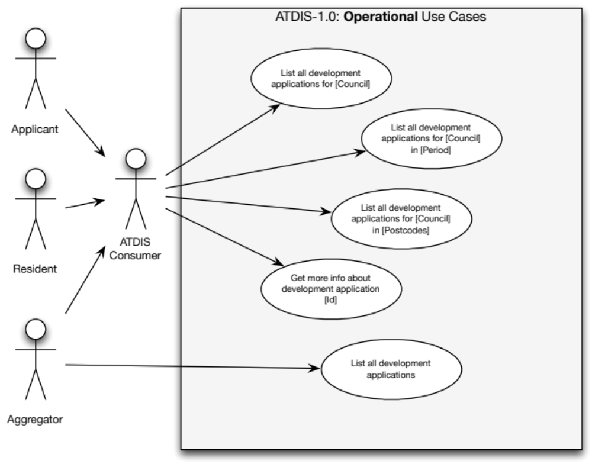
Figure 5: Operational use cases

List all development applications for [Council]
Allows an ATDIS consumer to return all active development applications for the specified Council. In this context, the specified Council would be the LGA that is hosting Vendor software capable of exposing application tracking data. For example:

REQ: GET http://www.examplecouncil.nsw.gov.au/atdis/1.0/applications.json
RES: 200 OK

In this case, [Council] is specified by virtue of accessing the feed published by the Council at their web address (www.examplecouncil.nsw.gov.au).

List all development applications for [Council] for [Period]
This is a refinement of 5.1.1 that allows for specification of a period in which to select development applications. The results returned should only be for development applications within the period.
By default, the feed must support querying of the lodgement_date field (see 4.3.1). For example:

REQ: GET http://www.examplecouncil.nsw.gov.au/atdis/1.0/applications.json?lodgement_date_start=YYYY-MM-DD&lodgement_date_end=YYYY-MM-DD
RES: 200 OK

The feed must also support querying by last_modified_date field (see 4.3.1). For example:

REQ: GET http://www.examplecouncil.nsw.gov.au/atdis/1.0/applications.json?last_modified_date_start=YYYY-MM-DD&last_modified_date_end=YYYY-MM-DD
RES: 200 OK

If the *_date_end field is not specified in the query string, the feed should assume that the request is for the single date specified in the last_modified_date_start or lodgement_date_start fields.

List all development applications for [Council] in [Postcodes]
This is a refinement of 5.1.1 that allows for a query to filter out only those development applications that occur within a specified list of postcodes. For example:

REQ: GET http://www.examplecouncil.nsw.gov.au/atdis/1.0/applications.json?postcode=2059
RES: 200 OK

To query across a number of postcodes, the consumer should separate multiple postcode values with a “,”:

REQ: GET http://www.examplecouncil.nsw.gov.au/atdis/1.0/applications.json?postcode=2059,2060
RES: 200 OK

Get more information about development application [Id]
Given information about a specific development application, the consuming system should be able to drill into a link to find more information. For example, if a Resident is accessing a Council’s web site via a browser, clicking a more info link would provide detailed information about the specific development application.

List all development applications
This is a use case for future consideration. The intent here is to allow a consumer to access aggregated application tracking data, which might come form a variety of LGAs across the state.

Notes on paging
If a requester specifies a page number to a request, then the feed must return just that page of data, as opposed to the entire set of items for the basic request. Requests should be parameterised using the “page=n” qualifier in the query string. For example:

REQ: GET http://www.examplecouncil.nsw.gov.au/atdis/1.0/applications.json?page=2
RES: 200 OK

In this case the feed should return the second page of data.
If the requester wishes to control the page size in items, it can be specified via the “count=k” qualifier in the query string. For example:

REQ: GET http://www.examplecouncil.nsw.gov.au/atdis/1.0/applications.json?page=2&count=20
RES: 200 OK

It is valid to specify both page number and the number of items per page in the same query string.

Specification Use Cases
Figure 6 describes the specification use cases for ATDIS-1.0.7:
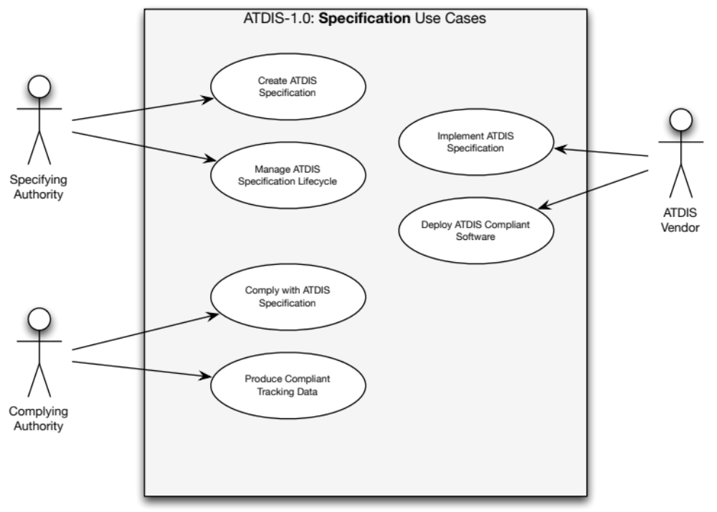
Figure 6: Specification use cases

Create ATDIS specification
This is the process by which the Specifying authority creates the specification. As of the pre-draft version of the document, the specification is a collaborative effort between the Department and Vendors of application tracking software.

Manage ATDIS specification lifecycle
The Department will manage publication of the specification and changes to it over time.

Comply with ATDIS specification
Complying Authorities (LGAs) collect application tracking data according to their preferred business processes and publish it using Vendor software according to the ATDIS-1.0.7 specification.

Produce compliant tracking data
LGAs produce tracking data by virtue of their daily activities operating as local Councils.

Implement ATDIS specification
Vendors use this specification to produce compliant software.

Deploy ATDIS-compliant software
Vendors work with LGAs to deploy compliant software into their Council’s IT infrastructure.

Distribution Channels

REST/JSON [L1]
It is mandatory for Level 1 compliance to produce a REST/JSON style feed of application tracking data.

REST/XML [L1]
Vendors can optionally produce an XML formatted version of their feed to achieve L1 compliance.
Transformation between REST/JSON and REST/XML is technically trivial.

Browser [L1]
This version of the ATDIS-1.0.7 specification concentrates on the data interchange format for application tracking feeds. However, it is mandatory for Level 1 compliance to have any feed data available via the REST/JSON interface also available for a browser-based interface accessible by a Resident using standards-compliant desktop and mobile operating system browsers.

Web Standards and Accessibility
All browser-distributed feed data must be compatible with W3C standards for HTML5 and CSS3.
It is also a mandatory requirement for compliance with ATDIS-1.0.7 that systems conform to the Australian Government’s Web Content Accessibility Guidelines (WCAG) version 2.0 (WCAG2.0). Full details of these accessibility guidelines can be found here:

http://webguide.gov.au/accessibility-usability/accessibility/

Desktop and mobile browser support
Data for consumption by browser clients must support the following desktop and mobile browsers:
Legend
- ✔ Must support
- C Can support
- – Not applicable

Desktop browser + operating system support
Support for the following desktop browser/OS combinations is mandatory for L1 compliance:
 |  | Windows |  |  |  | Mac OS X
 |  | XP | Vista |  | 7, 8 | 10.6.x | 10.7.x |  | 10.8.x
IE | 8.x | C | C |  | C | – | – |  | –
 | 9.x | C | ✔ |  | ✔ | – | – |  | –
 | 10.x | C | ✔ |  | ✔ | – | – |  | –
Firefox | 4.x | ✔ | ✔ |  | ✔ | ✔ | ✔ |  | ✔
 | Release Channel | ✔ | ✔ |  | ✔ | ✔ | ✔ |  | ✔
Chrome | Stable Channel | ✔ | ✔ |  | ✔ | ✔ | ✔ |  | ✔
Safari | 5.x | C  | C |  | C | ✔ | ✔ |  | ✔
 | 6.x | C  | ✔ |  | ✔ | ✔ | ✔ |  | ✔
Note: Because vendors constantly upgrade browser and operating system versions it is necessary to update this table from time to time to keep it in line with the most recent software. Additionally, both Firefox and Chrome now use a channel-based approach to upgrades that sees the browser automatically updated in-situ without need for user intervention.

Mobile browser + operating system support
Support for the following mobile browser/OS combinations is mandatory for L1 compliance:
 | Android |  | iOS
Browser | 3.x | 4.x | 4.x | 5.x |  | 6.x
Chrome | ✔ | ✔ | C | C |  | C
Mobile Safari | – | – | ✔ | ✔ |  | ✔
Note: Because vendors constantly upgrade browser and operating system versions it is necessary to update this table from time to time to keep it in line with the most recent software.

RSS [L3]
Although RSS is widely used across the web, it is better suited to syndication scenarios than it is data interchange of the form required by the ATDIS-1.0.7 specification.
For this reason, this version of the specification suggests that provision of an RSS feed of application tracking data is only necessary for Level 3 Extended compliance with the Specification.

Paging [L2]
In some circumstances, the data for a particular ATDIS query might be larger than is sensible to return in a single response. In this case, the feed can use paging to indicate to the client that the server has more data available. For example, a paged response to a request for all items within a postcode might look like this:

{
"response": [
{
"application": {
"info": {
"dat_id": "DA2013-0381",
“last_modified_date”: “2013-04-20T02:01:07Z”,
"description": "New pool plus deck",
"authority": "Example Council Shire Council",
"lodgement_date": "2013-04-20T02:01:07Z",
"determination_date": "2013-06-20T02:01:07Z",
"notification_start_date": "2013-04-20T02:01:07Z",
"notification_end_date": "2013-05-20T02:01:07Z",
"status": "OPEN"
},
"reference": {
"more_info_url": "http://www.examplecouncil.nsw.gov.au/atdis/1.0/applications/DA2013-0381"
},
"location": {
"address": "123 Fourfivesix Street Neutral Bay NSW 2089",
"land_title_ref": {
"lot": "10",
"section": "ABC",
"dpsp_id": "DP2013-0381"
}
}
}
},
{
"application": {
...
}
}
],
"count": 2,
"pagination": {
"previous": null,
"next": null,
"current": 1,
"per_page": 25,
"count": 100,
"pages": 1
}
}

In this format, the returned data is split up into three sections:
- response: contains the raw data of the response, paged according to the pagination block
- count: the number of items returned in this response
- pagination: information about how the returned data was paged relative to the full set of data available for that query. Within the pagination block, the following items indicate how the data was paged:
  - previous: the page number of the immediately preceding page, or null if this is the first page
  - next: the page number of the immediately following page, or null if this is the last page
  - current: the page number of the current page
  - per_page: the number of paged items returned per page
  - count: the total number of items available from the underlying data, unpaged
  - pages: the total number of pages available from the underlying data
Notes
- Paged data is at the discretion of the feed producer.
- In all cases, the response block must be provided by the feed producer, regardless of whether or not the feed is producing paged data.
- In a feed cannot handle pagination, then it can leave out the count and pagination blocks
Because back-end systems page data in a variety of different ways, specification of paging has been set at L2 for the ATDIS-1.0.7 version of the specification. However, Vendors should be aware that the paging specification would be promoted to L1 for the next point release, and that all responses should include the response block when returning data to the consuming system.

Compliance

Compliance requirements
The following items represent the canonical set of requirements for ATDIS-1.0.7 compliant feed of application tracking data. These requirements will be used during testing as the high-level criteria for compliance.
In this context “The System” refers to a Vendor application tracking system installed at a Complying Authority such as a Council.

General
- The System must provide an Internet-accessible feed to application tracking data
- The feed must be openly available to residents of NSW using standard Internet protocols such as HTTP or HTTPS.
- The feed must be available in a browser-rendered format.
- The feed must be available in machine-readable format.

Schema
- The feed must provide a list of application tracking records.
- The feed must support the data interchange schema as defined in section 4.3.
- For L1 compliance, the feed must be capable of supporting the following record types:
  - Info
  - Reference
  - Location
  - Events
  - Documents
  - People
  - Extended
- For L1 compliance, the System must be capable of populating the mandatory fields for the following record types:
  - 4.3.1 Info
  - 4.3.2 Reference
  - 4.3.3Location
  - 4.3.4 Events
  - 4.3.5 Documents
- For L1 compliance, the System should be capable of populating the optional fields for the following record types:
  - 4.3.1 Info
  - 4.3.2 Reference
  - 4.3.3 Location
  - 4.3.4 Events
  - 4.3.5 Documents
- For L2 compliance, the System must be capable of populating the mandatory record types for the following record types:
  - 4.3.6 People
- For L2 compliance, the System should be capable of populating the optional record types for the following record types:
  - 4.3.6 People
- For L3 compliance, the System may be capable of populating the optional record types for the following record types:
  - 4.3.7 Extended

Use cases
- The System must support the following operational use cases:
  - 5.1.1 List all development applications for [Council]
  - 5.1.2 List all development applications for [Council] in [Period]
  - 5.1.3 List all development applications for [Council] in [Postcode]
  - 5.1.4 Get more info about development application [Id]
- The System may support the following operational use cases:
  - 5.1.5 List all development applications
- The System must support the following specification use cases:
  - 5.2.3 Comply with ATDIS specification
  - 5.2.4 Produce compliant tracking data
  - 5.2.5 Implement ATDIS specification
  - 5.2.6 Deploy ATDIS-compliant software
Note, the following specification use cases are included in the requirements, but Vendors are not required to implement them in the System:
  - 5.2.1 Create ATDIS specification
  - 5.2.2 Manage ATDIS specification lifecycle

Distribution channels
- The System must provide a machine-readable feed in REST/JSON format.
- The System may provide a machine-readable feed in REST/XML format.
- The System must provide a feed available to Internet browser connections for all desktop and mobile browser and operating system combinations specified in section 6.3.
- The browser feed must conform to the NSW Government’s Web Content Accessibility Guidelines (WCAG) version 2.0.
- The System may provide an RSS-style feed. If the System provides an RSS feed, then data must be provided according to the ATDIS schema.
- The system should allow clients to consume data in pages. If a system offers paging, it must indicate paged data by populating the count and pagination properties of the response.

Compliance and certification process
In conjunction with this Specification, the Department will define test harness platform suitable for verifying that a particular application tracking system complies with the Specification. The line items in section 7.1 describe the individual requirement items that the test harness will verify.
At a mutually agreeable time between the Department, LGA and Vendor, an execution run will be organised for the implementation. The goal of the certification process is to validate that the vendor system produces a feed that complies with the mandatory requirements of the Specification, and if the vendor system is capable of providing the optional/best practice data, that it is also correctly provided.
This test execution run will involve:
- A test script will be run against the vendor system running at the LGA
- The script will access the feed via a URL specified by the Complying Authority
- The script will attempt to query data from the feed according to the use cases specified in 5.1
- For each use case, the script will:
  - Validate that all mandatory fields defined in 4.3 are present for each compliance level
  - Validate that when any optional field is provided that it complies with the field formats defined in 4.3
Additionally, a manual inspection test will be performed that will:
- Validate by manual review that the LGA’s implementation system provides data to supported browsers as per 6.3 and according to the data items defined in 4.3

Obtaining certification
The Department is interested in ensuring that LGA implementations of application tracking systems comply with this Specification. Optionally, Vendors may wish to obtain Vendor certification of a test or staging installation of their system using sample data.

Using "ATDIS-1.0.7 Data Interchange Specification Compliant" in Vendor software marketing
Vendors may make use of the certification process in their marketing following successful completion of a compliance test execution.
The Department will notify the LGA in writing upon meeting the requirements of the Specification.

Lifecycle

Version history
This is: ATDIS-1.0.7 Data Interchange Specification [version: 1.0, revision: 30]

Changed in this version

Data items
- 4.3.4 Events – promoted from Level 2 Optional to Level 1 Mandatory
- 4.3.5 Documents – promoted from Level 2 Optional to Level 1 Mandatory

Use cases
- None identified

Distribution channels
- None identified

Deprecated in this version

Data items
- None identified

Use cases
- None identified

Distribution channels
- None identified

Planned for deprecation in the next version

Data items
- None identified

Use cases
- Specification use cases (all)

Distribution channels
- RSS

Planned for addition in the next release

Data items
- None identified

Use cases
- None identified

Distribution channels
- Pagination, including use of count and pagination blocks for paging information will be promoted to L1 mandatory in the next major release.

Appendix 1: Future possibilities
Although this section does not form part of the compliance process, it is worth presaging possible future ideas for uses of the data items and feeds imagined by the ATDIS-1.0.7 specification.

Subscription and publication of ATDIS events
The ability to subscribe for alerts on changes in state of development applications would make it very easy for Residents to be informed about applications taking place in their local areas.

Extended/enhanced attribute publication
Vendors of application tracking software have different capabilities that will make it easier to comply with the mandatory L1 capabilities of the specification. This presents an opportunity to provide extensions to the basic L1 and L2 capabilities by adding innovative functionality.
The Department, in stewarding this process, hopes to influence vendors to add more and more capability over time into the core of the specification by pushing what it believes to be best practice. This will mean that what is extended or optional in one release is likely to be promoted to a mandatory part of the specification in a subsequent release.

Appendix 2: Examples of compliant ATDIS-1.0.7 requests and responses

Obtain a list of all applications
Request

REQ: GET http://www.examplecouncil.nsw.gov.au/atdis/1.0/applications.json
RES: 200 OK

Response

{
"response": [
{
"application": {
"info": {
"dat_id": "DA2013-0381",
“last_modified_date”: “2013-04-20T02:01:07Z”,
"description": "New pool plus deck",
"authority": "Example Council Shire Council",
"lodgement_date": "2013-04-20T02:01:07Z",
"determination_date": "2013-06-20T02:01:07Z",
"notification_start_date": "2013-04-20T02:01:07Z",
"notification_end_date": "2013-05-20T02:01:07Z",
"status": "OPEN"
},
"reference": {
"more_info_url": "http://www.examplecouncil.nsw.gov.au/atdis/1.0/applications/DA2013-0381"
},
"location": {
"address": "123 Fourfivesix Street Neutral Bay NSW 2089",
"land_title_ref": {
"lot": "10",
"section": "ABC",
"dpsp_id": "DP2013-0381"
}
}
}
},
{
"application": {
...
}
}
],
"count": 2,
"pagination": {
"previous": null,
"next": null,
"current": 1,
"per_page": 25,
"count": 100,
"pages": 1
}
}

Obtain a list of all applications for a set of postcodes
Request

REQ: GET http://www.examplecouncil.nsw.gov.au/atdis/1.0/applications.json?postcode=2089,2090
RES: 200 OK

Response

{
"response": [
{
"application": {
"info": {
"dat_id": "DA2013-0381",
“last_modified_date”: “2013-04-20T02:01:07Z”,
"description": "New pool plus deck",
"authority": "Example Council Shire Council",
"lodgement_date": "2013-04-20T02:01:07Z",
"determination_date": "2013-06-20T02:01:07Z",
"notification_start_date": "2013-04-20T02:01:07Z",
"notification_end_date": "2013-05-20T02:01:07Z",
"status": "OPEN"
},
"reference": {
"more_info_url": "http://www.examplecouncil.nsw.gov.au/atdis/1.0/applications/DA2013-0381"
},
"location": {
"address": "123 Fourfivesix Street Neutral Bay NSW 2089",
"land_title_ref": {
"lot": "10",
"section": "ABC",
"dpsp_id": "DP2013-0381"
}
}
}
},
{
"application": {
...
}
}
],
"count": 2,
"pagination": {
"previous": null,
"next": null,
"current": 1,
"per_page": 25,
"count": 100,
"pages": 1
}
}

Appendix 3: Carpadium Pty Ltd

About Carpadium
Carpadium is a boutique Sydney-based consulting firm specialising in technology strategy, enterprise architecture and program management. Our Consulting Directors have significant experience delivering complex programs in financial services for online and mobile, as well as unique product development experience building enterprise-class software-as-a-service offerings in security, electronic presentment and payments.
- Matthew Sinclair, Director – Matthew is a technology strategy specialist with 18 years experience in software engineering, consulting and product development. Matthew has delivered highly complex technology systems in the telecommunications, financial services and payments sectors. Matthew has been involved in the delivery of projects ranging from network analysers, to flight simulators and more recently high-performance mission-critical EFT payments transaction switching and Tier-1 online/mobile banking. @matthewsinclair
- Andrew McDonald, Director – Andrew has more than 18 years of senior program delivery experience in the banking and financial services sector. In the last 5 years, Andrew has focused on a number of large scale programs across Australia’s banking community, including AML, process redesign, online banking and identity / security management. Working at the heart of Australia's tier-1 retail online banking environment, Andrew understands and has experienced the issues in delivering business critical programs in a competitive and increasingly frugal project environment.

Carpadium's role in the specification process
The NSW Department of Planning & Infrastructure engaged Carpadium to coordinate drafting of the ATDIS-1.0.7 specification.
As an independent organisation with no interest in the commercial software market for application tracking software, Carpadium’s role is to prepare the technical components of the specification, and to work with interested vendors to incorporate their requirements and feedback into the final specification.
We understand the commercial sensitivities given the competitive landscape and as such, we can act as an independent third party. Unless specifically instructed by the vendor or the Department, all communications with Carpadium will be in the strictest confidence.

Note: Responses must be pagination-aware, please see 6.5 for more details.
Firefox calls this “release channel” and Chrome calls this “stable channel”.

